MICRO WORKSHOP & MEETUP SCHEDULER
@CREATIVITY THINK (9483175986/7019689991)

ABSTRACT:
Micro Workshop & Meetup Scheduler is a dynamic web-based platform designed for organizing small-scale workshops, meetups, and community training sessions. This system enables users to browse events, register for available seats, receive confirmation and reminders, attend sessions, and provide post-event feedback. Organizers and administrators can create events, set seat limits, manage registrations, track attendance, review analytics, and export reports. Built using Django REST Framework for backend operations and React with calendar components on the frontend, the system ensures an efficient, intuitive, and structured event management experience..

INTRODUCTION OF THE PROJECT:
Workshops and meetups are essential for knowledge sharing in communities, colleges, and professional groups. However, organizers often struggle to manage registrations, handle limited seating, track attendance, and gather feedback efficiently. Traditional tools like Google Forms or manual spreadsheets lack automation and analytics.
Micro Workshop & Meetup Scheduler solves these issues by offering a centralized system where users can discover events and register seamlessly, while organizers can efficiently manage event lifecycles. This structured approach enhances the experience for both participants and organizers and ensures smooth workshop execution..

PROJECT OBJECTIVES:

• Provide a user-friendly portal to browse workshops and meetups
• Enable attendees to register for free or limited-seat events
• Send confirmation and automated reminders before event time
• Allow attendees to submit post-event ratings and feedback
• Provide organizers with tools to create and manage events
• Track registrations and attendance in real time
• Display analytics such as attendance count, feedback stats, and engagement levels
• Allow organizers to export event reports and attendee lists
• Support broadcast updates for schedule changes or reminders

PROBLEM OF THE STATEMENT:
Organizing micro workshops requires managing attendees, seat limits, schedules, and feedback efficiently. Manual methods often result in registration overlaps, poor attendance tracking, and lack of event insights. There is a need for a structured, automated system that simplifies event creation, participant management, and analytics. The Micro Workshop & Meetup Scheduler addresses these challenges by providing a digital platform that streamlines scheduling, registration, communication, and analysis..

MOTIVATION OF THE PROJECT:
• To simplify the process of organizing workshops and meetups
• To provide a modern and efficient alternative to manual registration systems
• To allow users to easily discover, register, and attend events
• To ensure organizers can track seat availability and attendance live
• To enable collection of structured feedback for event quality improvement
• To support communities, colleges, and trainers in hosting professional events
• To offer analytics and reporting tools for performance evaluation

BLOCK DAIGRAM OF PROJECT:

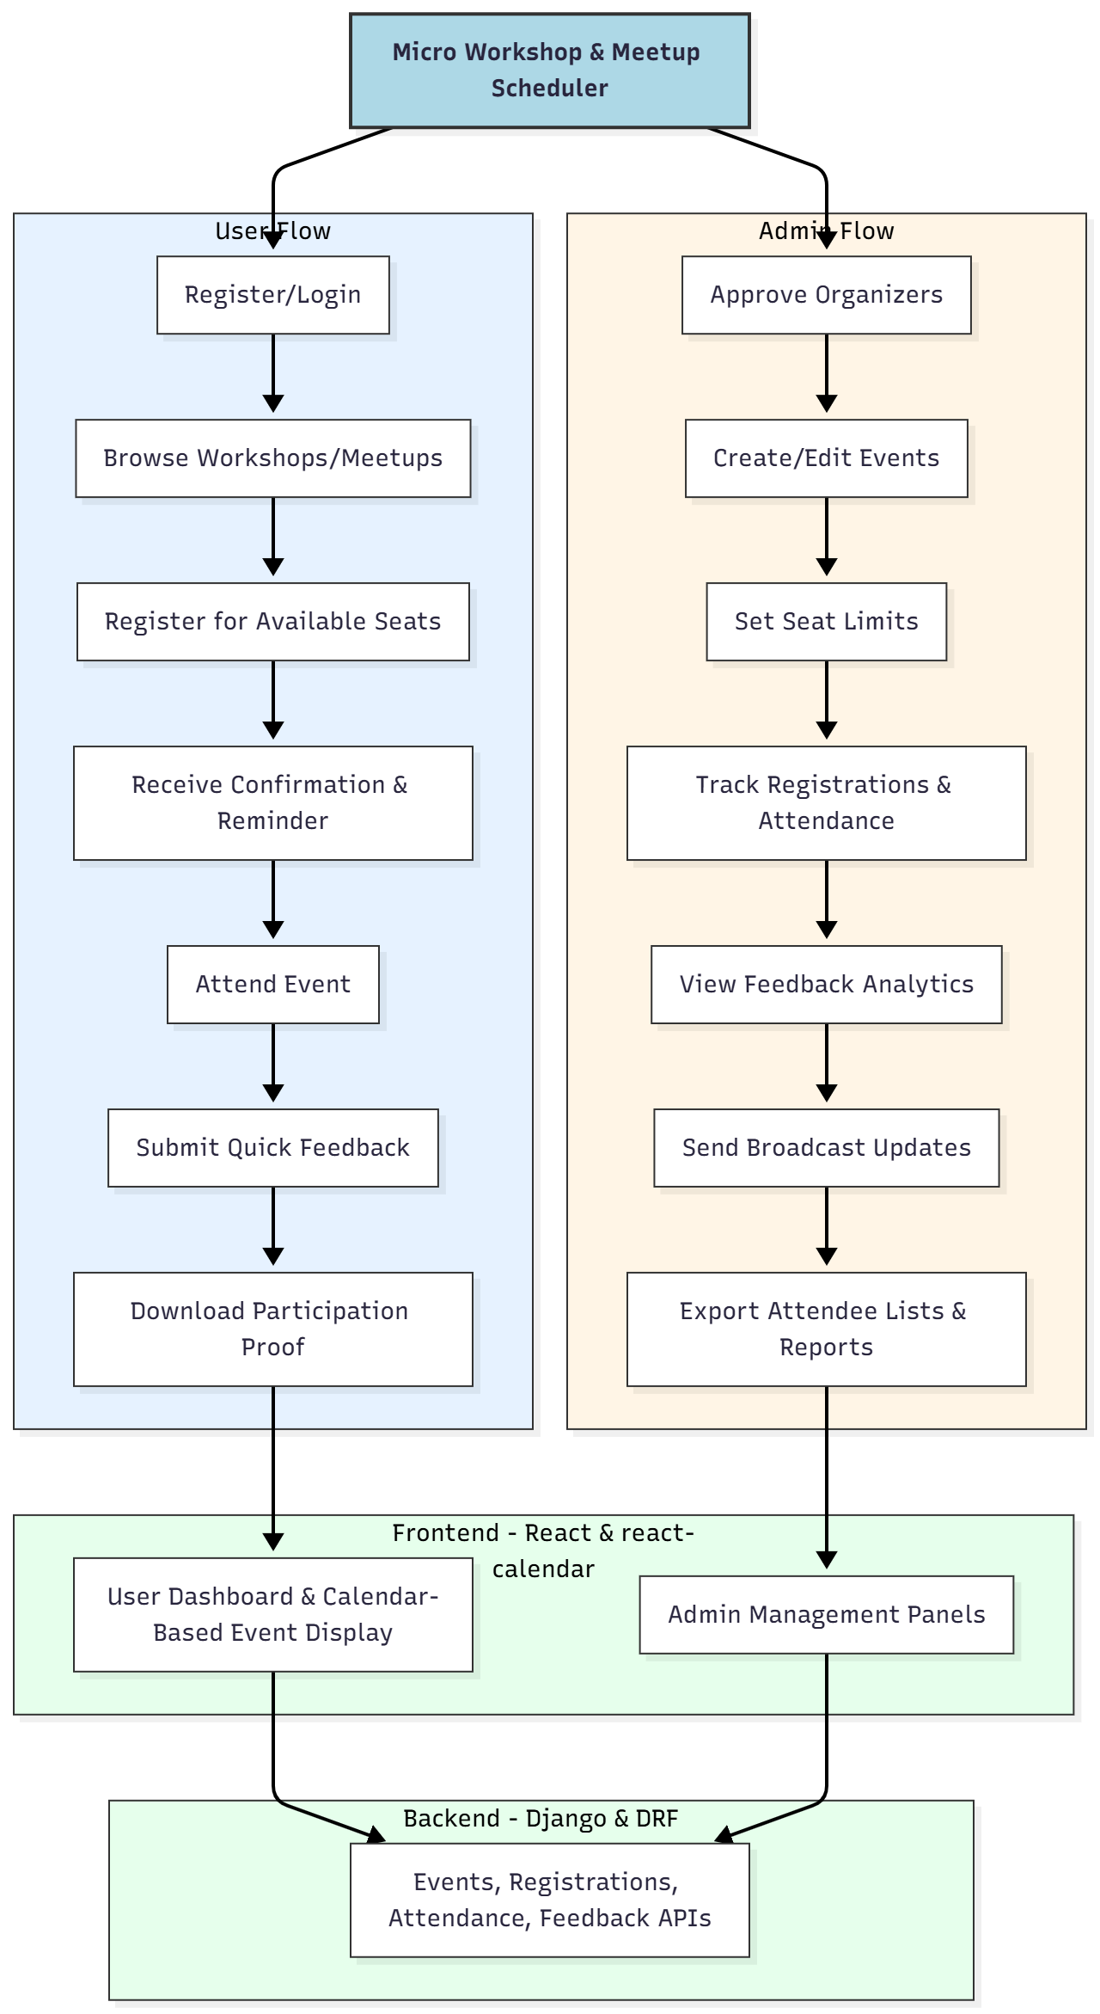

WORKING OF THE PROJECT:
Users register or log in to the platform and browse upcoming workshops or meetups using a calendar-based view. They can view event details, seat availability, and register instantly. Once registered, the system sends confirmation messages and reminder notifications.
During the event, attendance is tracked digitally. After attending, users submit quick feedback and may download participation certificates.
Organizers, after admin approval, create and manage events, define seat limits, and monitor registrations. The dashboard presents real-time attendance stats, feedback trends, and engagement analytics. Organizers can send broadcast updates to all registered attendees and export event reports and attendee lists for documentation and analysis..

SOFTWARE REQUIREMENT:
- Backend:
  - Python 3.x
  - Django
  - Django REST Framework
  - SQLite/PostgreSQL
- Frontend:
  - Node.js and npm
  - React.js
  - Axios
- Development Tools:
  - Visual Studio Code
  - Postman (for testing APIs)
  - Git/GitHub (for version control)
- Server/Deployment (Optional):
  - Gunicorn, Nginx, or Heroku/AWS for hosting

ADVANTAGES OF THE PROJECT:

• Automated event scheduling and attendee management
• Eliminates manual registration and attendance tracking
• Real-time visibility of seat availability
• Quick and easy participant feedback system
• Automated confirmations and reminders improve attendance rates
• Analytics help event organizers evaluate performance
• Event reports and attendee lists simplify documentation
• Ideal for recurring workshops, seminars, and meetups

APPLICATIONS OF THE PROJECT:
• Training institutes and workshops
• College clubs and student communities
• Corporate micro-events and team development meets
• Local community groups and organizations
• Professional trainers and speakers
• Hobby clubs and social learning groups

REFERENCES:

- Django REST Framework Documentation — Django Software Foundation. Django Documentation. Available: https://docs.djangoproject.com/
- Django REST Framework. DRF Documentation. Available: https://www.django-rest-framework.org/
- React. React Official Documentation. Available: https://reactjs.org/docs/getting-started.html
- Redux. Redux Documentation. Available: https://redux.js.org/introduction/getting-started
- PostgreSQL Global Development Group. PostgreSQL Documentation. Available: https://www.postgresql.org/docs/
- MySQL. MySQL Reference Manual. Available: https://dev.mysql.com/doc/
- Git. Git Documentation. Available: https://git-scm.com/doc
- Node.js. Node.js Documentation. Available: https://nodejs.org/en/docs/
- Axios. Axios Documentation. Available: https://axios-http.com/docs/intro
- Socket.io Documentation – https://socket.io/docs/

